Year 11 Homework
Subject | Religious Education
Cycle | 1 | Week | 9
Hand in Date
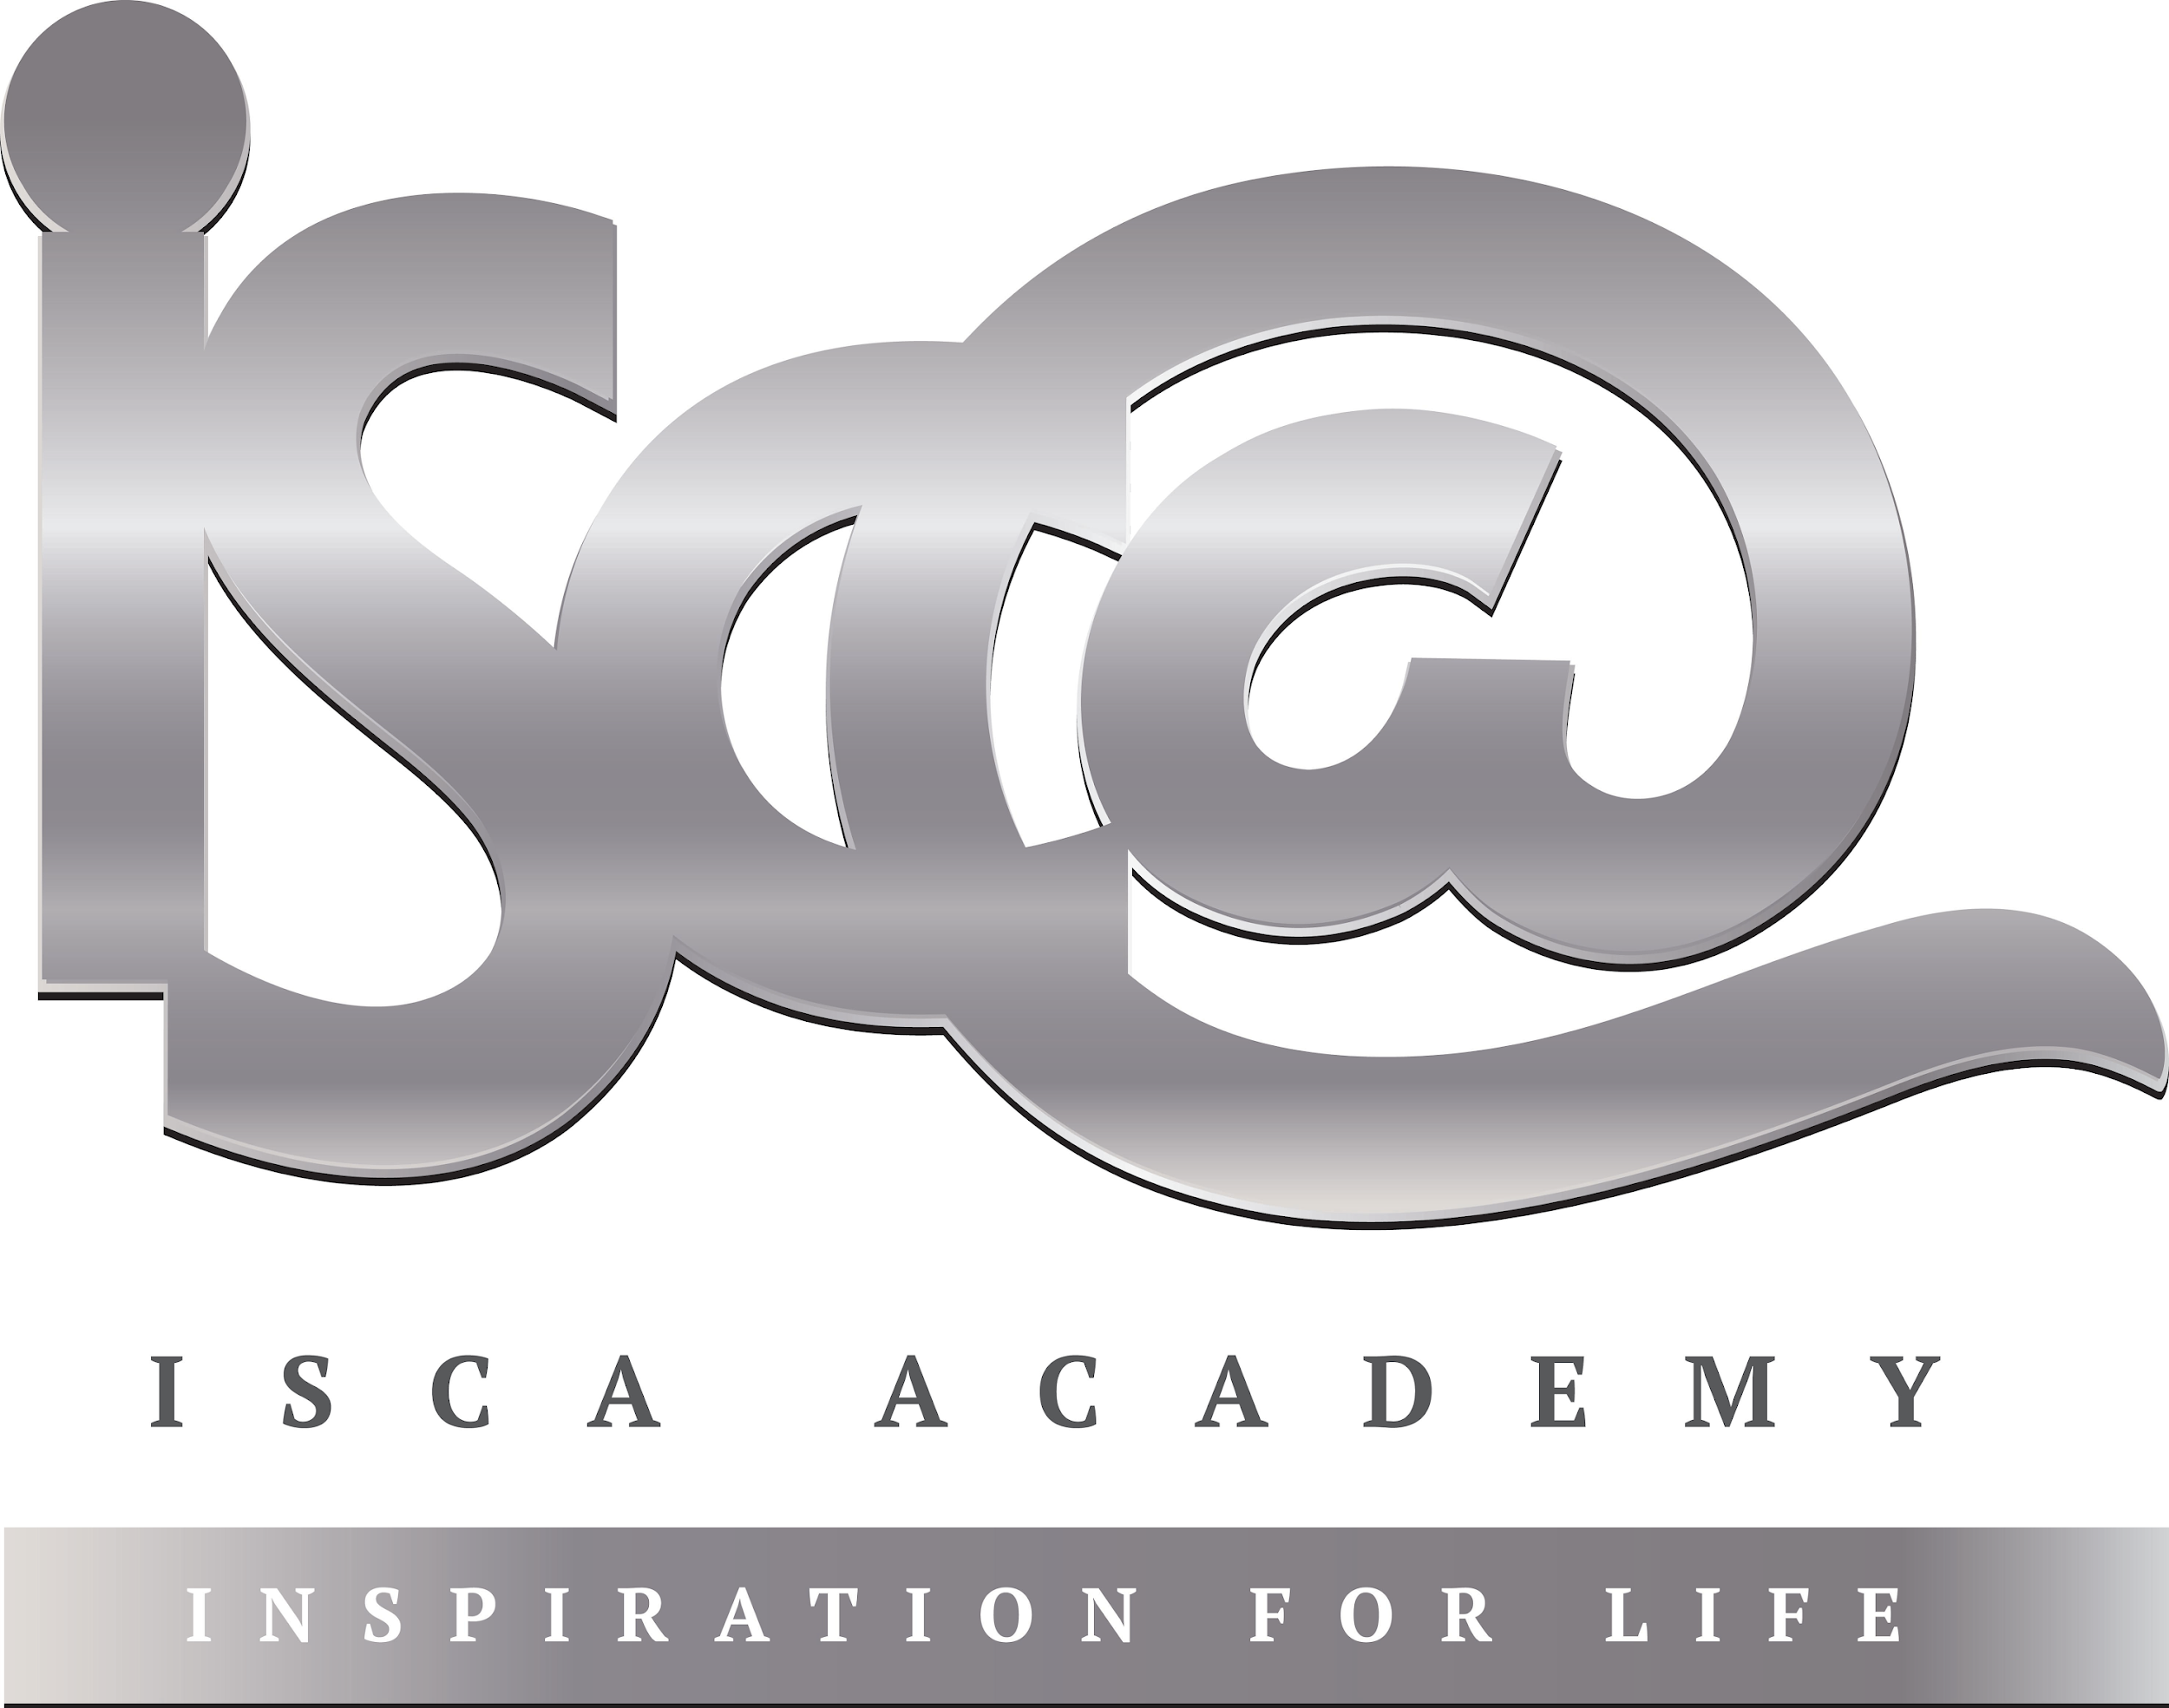
Recap of Themes:

Explain two contrasting religious opinions on the aim of punishment [5]

___________________________________________________________________________________________________________________________________________________________________________________________________________________________________________________________________________________________________________________________________________________________________________________________________________________________________________________

Explain two religious opinions on abuse of the environment [5]

___________________________________________________________________________________________________________________________________________________________________________________________________________________________________________________________________________________________________________________________________________________________________________________________________________________________________________________

Mock Revision:
Buddhism (Beliefs and Practices)

- Bodhisattvas and Arhats
- Four Noble Truths (and eightfold path)
- The Life of the Buddha (Birth, 4 Sights, Ascetic, Enlightenment)
- Buddhist Meditation / Prayer
- Death and Mourning Ceremonies (Sky Burial, Money to Charity, Pure Land)
- Vihara / Temple

Revise these topics for your Buddhism mock paper.
This can be done through creating revision cards, mind maps, rewriting information out etc.

