Year 11 Homework French
Name
Cycle | 1 | Week | 7
Hand in Date

Conjugate TRAVAILLER in the Imperfect:
I used to work_________________________
You used to work (s) ____________________
He used to work _______________________
We used to work ______________________
You used to work (pl) ___________________
They used to work _____________________

You should spend time on Quizlet practicing this week’s vocabulary.
It is important to listen to the vocabulary as well as look at it. Practice saying it out loud.

Week 7 – Variety of tenses self-test
I have
I have worked
I used to work
I am going to help
I sat
I would like
I am thinking
I am (subjunctive)
I want
It will be
Name the tense
J’habiterais
Je suis en train de parler
Je fasse
J’étudiais
Je vais voyager
Je suis
Je continuerai
Je suis allé

Strategy: Role Play
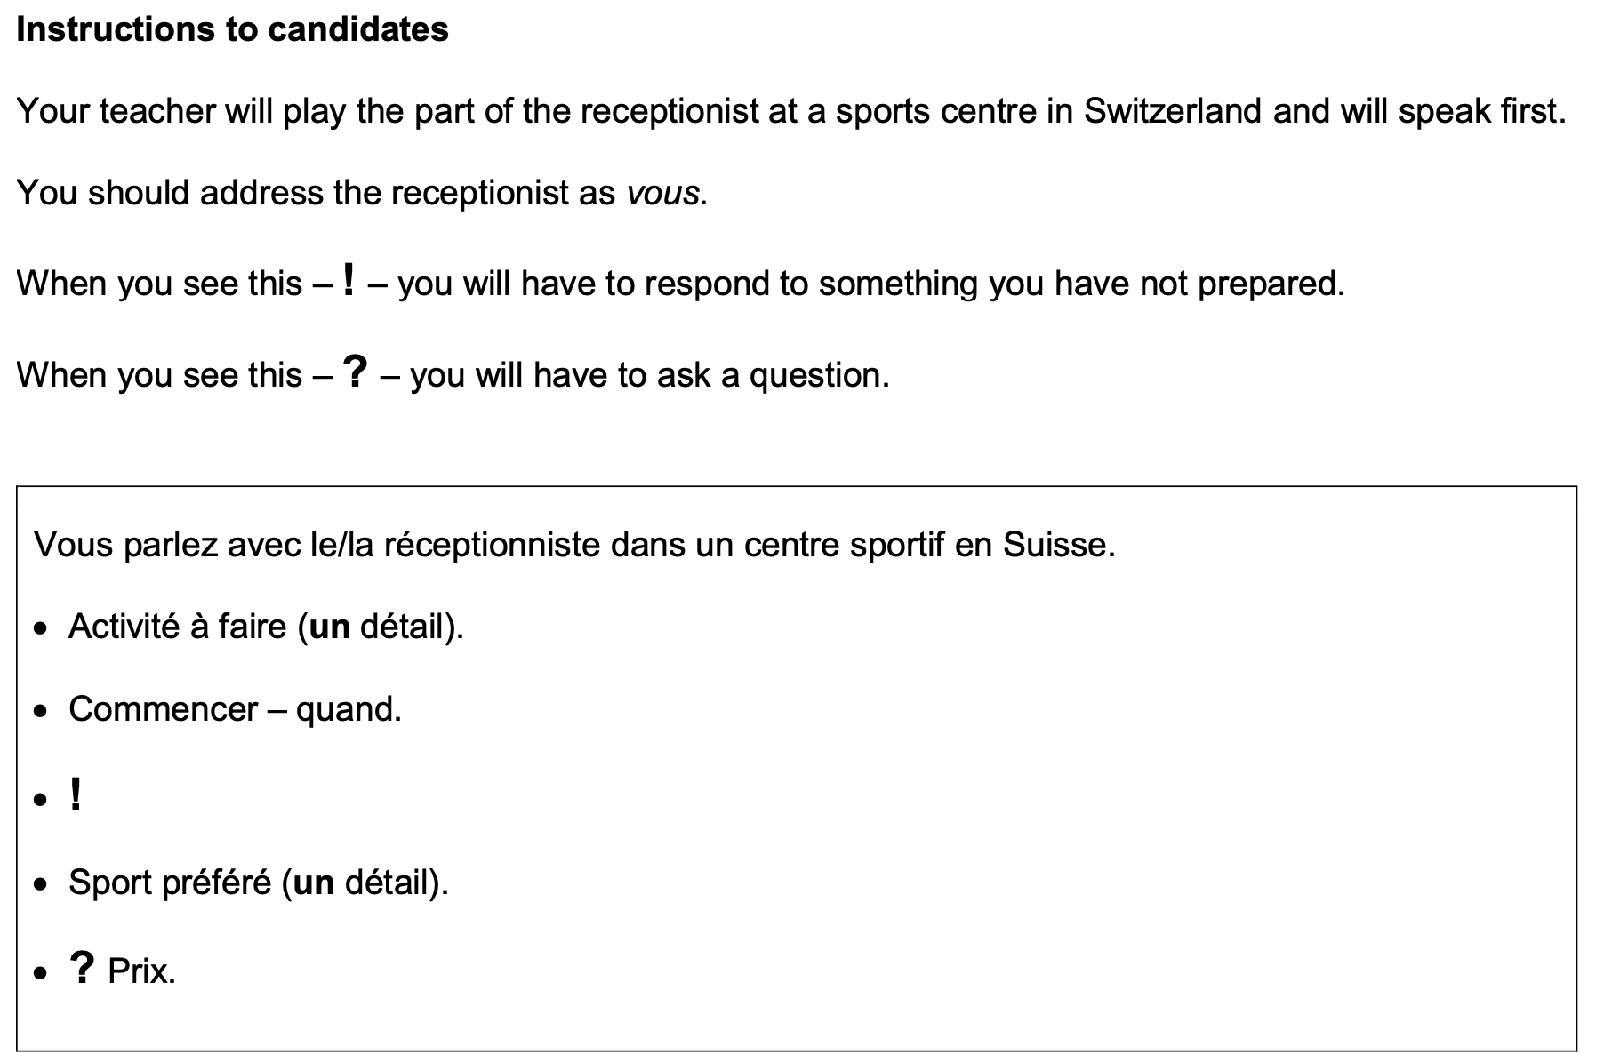
C’est pour combien de personnes?

- Highlight the context. Where are you? Who are you talking to?

______________________________________________________________________________

- Translate the bullets into English (do this above).

- Draft a response in French using FULL sentences each time.

- ____________________________________________________________________________________________________________________________________________________________
- ______________________________________________________________________________
______________________________________________________________________________
- ____________________________________________________________________________________________________________________________________________________________
- ____________________________________________________________________________________________________________________________________________________________
- ______________________________________________________________________________
_____________________________________________________________________________________

