Year 11 Homework French
Name
Cycle | 1 | Week | 8
Hand in Date

Conjugate VOYAGER in the Future tense:
I will travel ____________________________
You will travel (s) _______________________
He/she will travel ______________________
We will travel _________________________
You will travel (pl) ______________________
They will travel ________________________

You should spend time on Quizlet practicing this week’s vocabulary.
It is important to listen to the vocabulary as well as look at it. Practice saying it out loud.

Week 8 If clauses self-test
he will speak
they will speak
I will speak
you will speak (pl)
we will speak
you will speak (s)
If I get good grades
If I am lucky
If I don’t understand
I will travel the world
My teacher will help me
I’m going to go to university

Strategy: Photo Card
Highlight the theme. What are you talking about? ______________________________________________

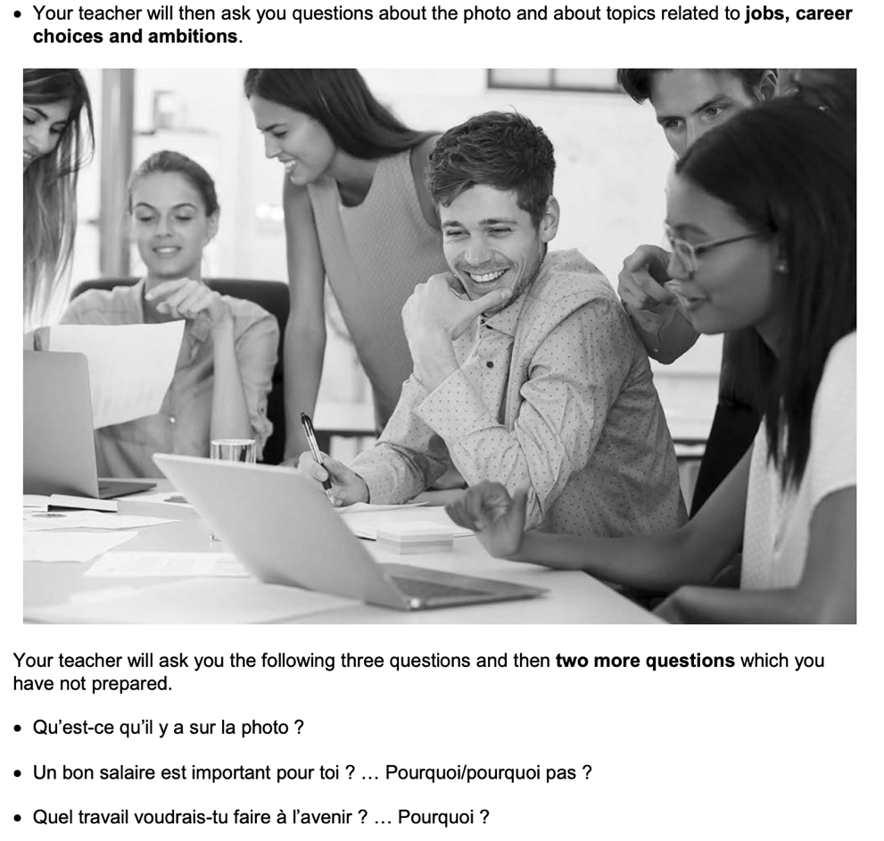
- PALMW the first question.

P ____________________________
____________________________
A ___________________________
___________________________
L ____________________________
____________________________
M ___________________________
___________________________
W ___________________________
___________________________

- Draft a response to question 2 in French using an opinion + justification + 1 more sentence.
_________________________________________________________________________________ _________________________________________________________________________________
_________________________________________________________________________________
- Draft a response to question 3 in French using 3 sentences.
_________________________________________________________________________________ _________________________________________________________________________________
_________________________________________________________________________________
- Prepare an answer to this using 1 sentence.
Pour toi, c’est important de gagner beaucoup d’argent? ... Pourquoi / pourquoi pas?
_________________________________________________________________________________
- Prepare an answer to this using 1 sentence.
Qu’est-ce tu as fait dans le passé pour gagner de l’argent?
_________________________________________________________________________________

