Year 11 Homework French
Name
Cycle | 1 | Week | 9
Hand in Date

Conjugate PARLER in the Pluperfect:
I had spoken __________________________
You had spoken (s) _____________________
He / she had spoken ____________________
We had spoken ________________________
You had spoken (pl) ____________________
They had spoken _______________________

You should spend time on Quizlet practicing this week’s vocabulary.
It is important to listen to the vocabulary as well as look at it. Practice saying it out loud.

Week 9 – Jobs and future plans self-test
engineer
gap year
farmer
A levels
vet
lawyer
wages, salary
apprentice
doctor
journalist
nurse
company
computer technician
part-time job
college
work
accountant
degree
hairdresser

Strategy: Role Play
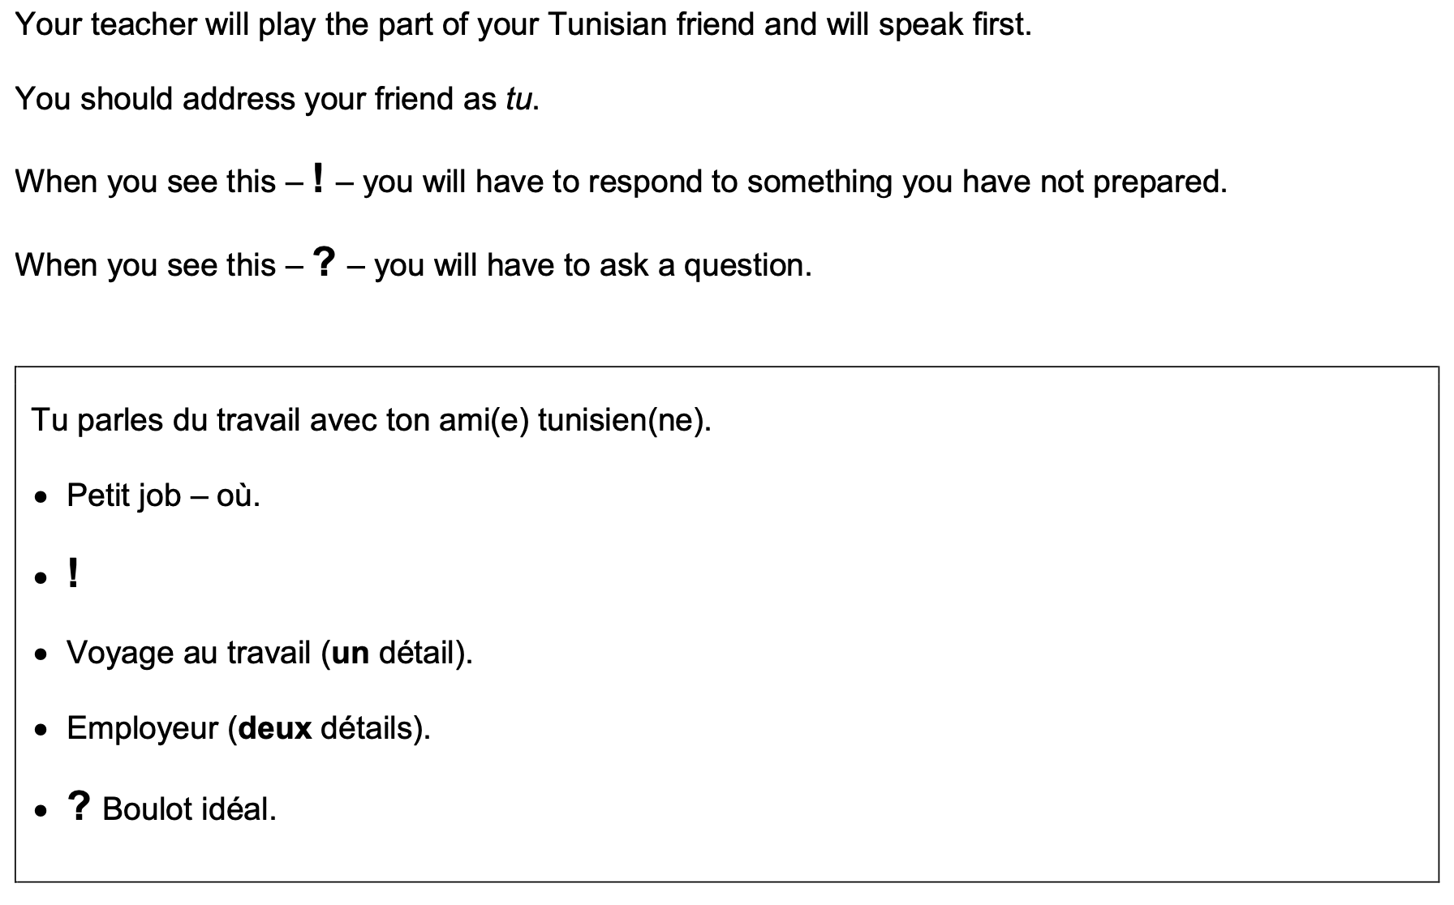
Combien d’argent est-ce que tu gagnes?

- Highlight the context. Where are you? Who are you talking to?

______________________________________________________________________________

- Translate the bullets into English (do this above).

- Draft a response in French using FULL sentences each time.

- ____________________________________________________________________________________________________________________________________________________________
- ______________________________________________________________________________
______________________________________________________________________________
- ____________________________________________________________________________________________________________________________________________________________
- ____________________________________________________________________________________________________________________________________________________________
- ______________________________________________________________________________
_____________________________________________________________________________________

