Year 11 Homework Spanish
Name
Cycle | 1 | Week | 7
Hand in Date

Conjugate TRABAJAR in the Imperfect Tense:
I used to work_________________________
You used to work (s) ____________________
He used to work _______________________
We used to work _______________________
You used to work (pl) ___________________
They used to work ______________________

You should spend time on Quizlet practicing this week’s vocabulary.
It is important to listen to the vocabulary as well as look at it. Practice saying it out loud.

Week 7 – Variety of tenses self-test
I have
I have worked
I used to work
I am going to help
I did
I would like
I am thinking
I have (subjunctive)
It will be
Name the tense
He visto
Estoy viviendo
Sea
Estudiaba
Voy a viajar
Soy
Continuaré
Fui
Ganaría

Strategy: Role Play
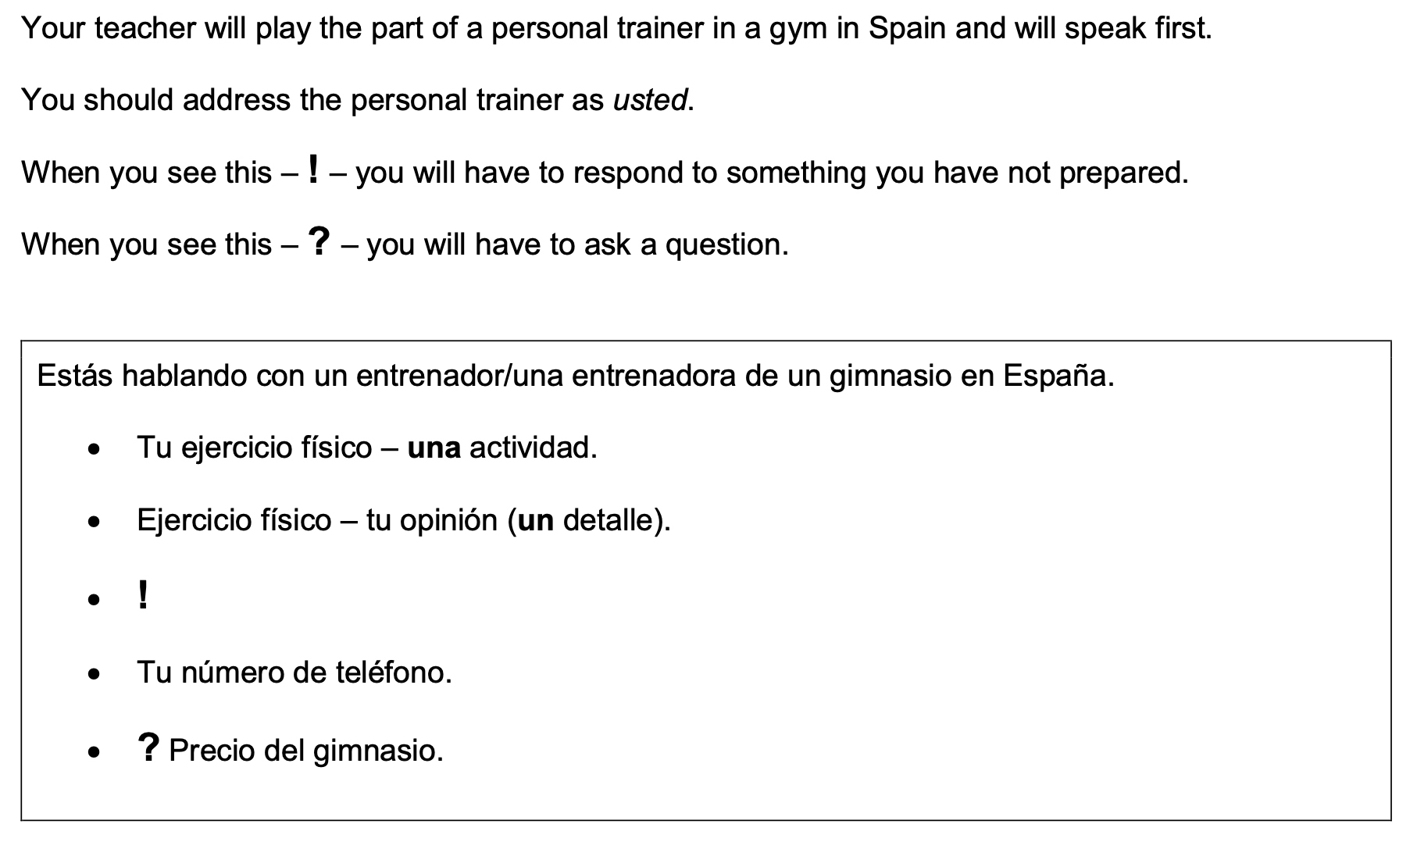
¿Cuántos días por semana quiere venir al gimnasio?

- Highlight the context. Where are you? Who are you talking to?

______________________________________________________________________________

- Translate the bullets into English (do this above).

- Draft a response in Spanish using FULL sentences each time.

- ____________________________________________________________________________________________________________________________________________________________
- ______________________________________________________________________________
______________________________________________________________________________
- ____________________________________________________________________________________________________________________________________________________________
- ____________________________________________________________________________________________________________________________________________________________
- ______________________________________________________________________________
_____________________________________________________________________________________

