Year 11 Homework Spanish
Name
Cycle | 1 | Week | 8
Hand in Date

Conjugate VIAJAR in the Future tense:
I will travel ____________________________
You will travel (s) _______________________
He/she will travel ______________________
We will travel _________________________
You will travel (pl) ______________________
They will travel ________________________

You should spend time on Quizlet practicing this week’s vocabulary.
It is important to listen to the vocabulary as well as look at it. Practice saying it out loud.

Week 8 If clauses self-test
he will speak
they will speak
I will speak
you will speak (pl)
we will speak
you will speak (s)
If I get good marks
If I am lucky
If I don’t understand
I will travel the world
My teacher will help me
I will go to university

Strategy: Photo Card
Highlight the theme. What are you talking about? ______________________________________________
- PALMW the first question.

P ____________________________
____________________________
A ___________________________
___________________________
L ____________________________
____________________________
M ___________________________
___________________________
W ___________________________
___________________________

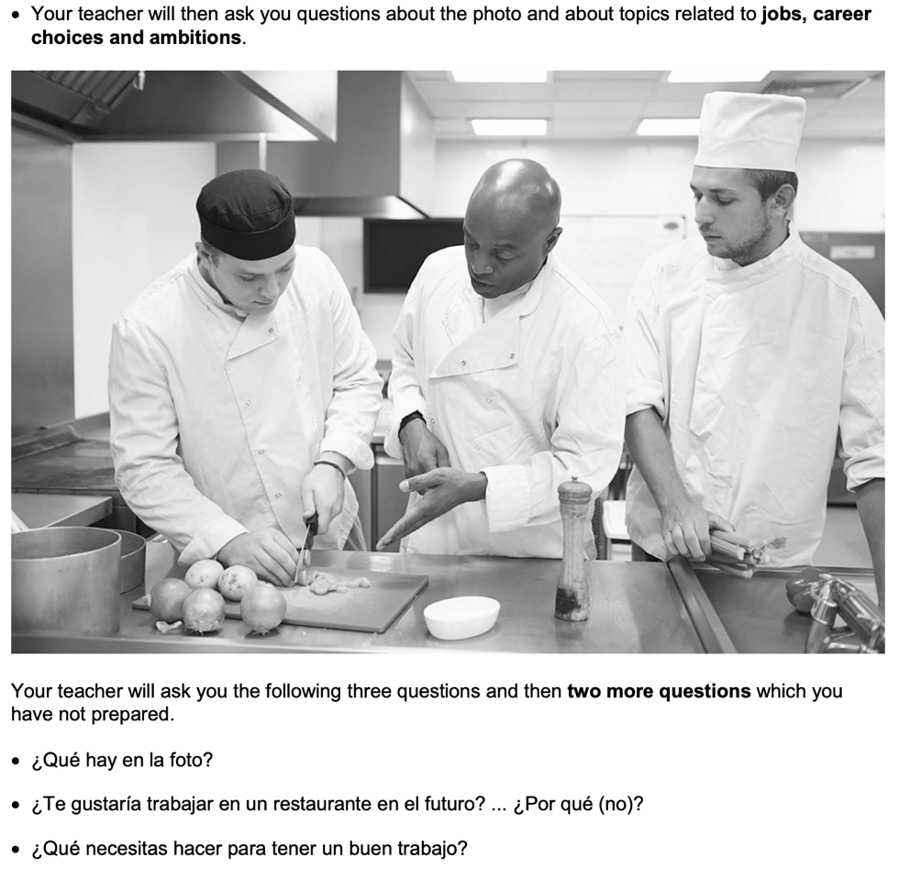

- Draft a response to question 2 in Spanish using an opinion + justification + 1 more sentence.
_________________________________________________________________________________ _________________________________________________________________________________
_________________________________________________________________________________
- Draft a response to question 3 in Spanish using 3 sentences.
_________________________________________________________________________________ _________________________________________________________________________________
_________________________________________________________________________________
- Prepare an answer to this using 1 sentence.
Para ti, ¿es importante ganar mucho dinero? ... ¿Por qué (no)?
_________________________________________________________________________________
- Prepare an answer to this using 1 sentence.
¿Qué hiciste en el pasado para ganar dinero?
_________________________________________________________________________________

