Year 11 Homework Spanish
Name
Cycle | 1 | Week | 9
Hand in Date

Conjugate GANAR in the Subjunctive:
I earn ________________________________
You earn (s) ___________________________
He / she earns _________________________
We earn ______________________________
You earn (pl) __________________________
They earn ____________________________

You should spend time on Quizlet practicing this week’s vocabulary.
It is important to listen to the vocabulary as well as look at it. Practice saying it out loud.

Week 9 – Jobs and future plans self-test
engineer
gap year
farmer
A levels
vet
lawyer
wages, salary
apprentice
doctor
journalist
nurse
company
apprenticeship
businessman/woman
training
job, employment
accountant
degree
hairdresser
boss

Strategy: Role Play
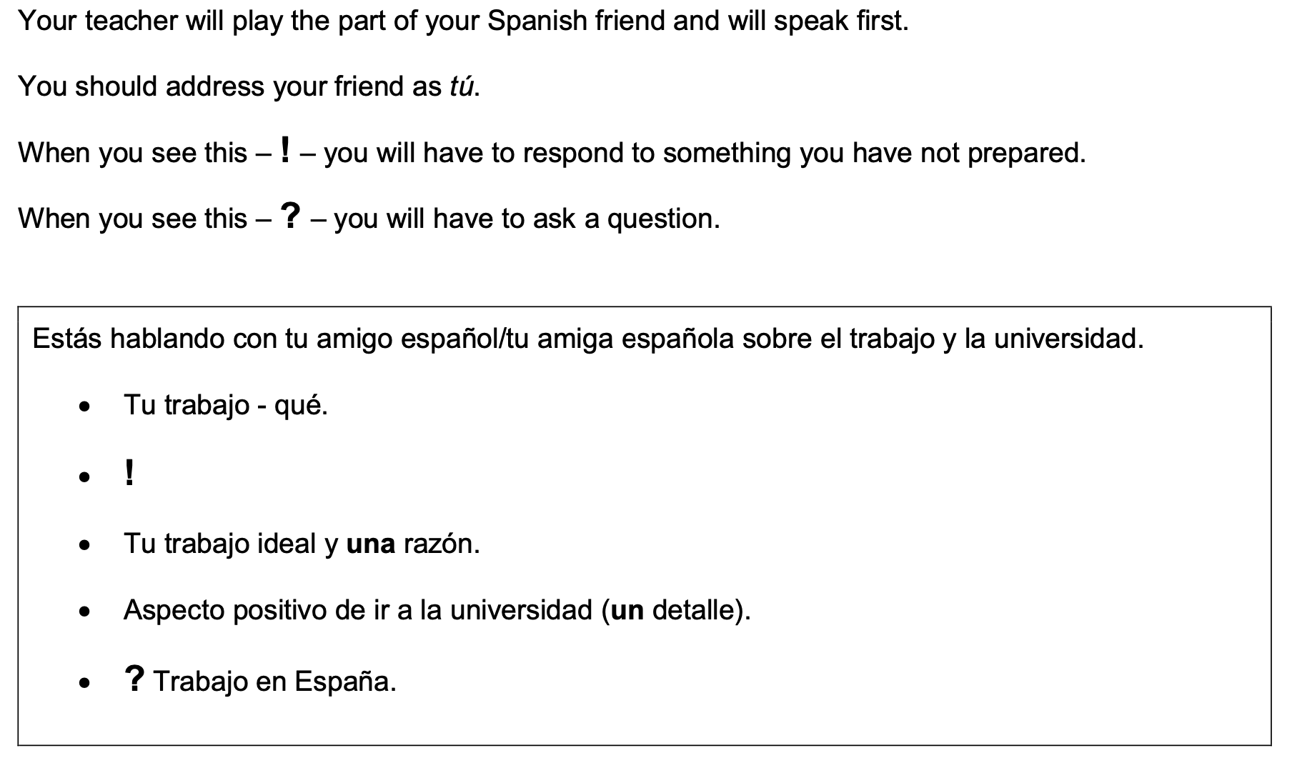
¿Qué compras con tu dinero?

- Highlight the context. Where are you? Who are you talking to?

______________________________________________________________________________

- Translate the bullets into English (do this above).

- Draft a response in Spanish using FULL sentences each time.

- ____________________________________________________________________________________________________________________________________________________________
- ______________________________________________________________________________
______________________________________________________________________________
- ____________________________________________________________________________________________________________________________________________________________
- ____________________________________________________________________________________________________________________________________________________________
- ______________________________________________________________________________
_____________________________________________________________________________________

