Year 11 Homework Creative iMedia
Name
Cycle | 1 | Week | 7
Hand in Date

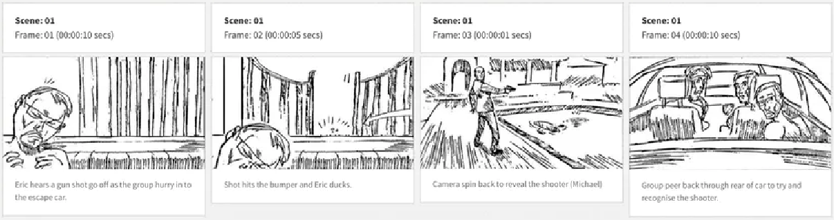

Evaluate the above storyboard, to assess its for suitability for use.
3 Positive aspects of this storyboard | Why each aspect is an advantage for the film making process.
1
2
3
3 Negative aspects of this storyboard (does it lack specific detail?) | Why each aspect is a disadvantage for the film making process.
1
2
3

