Year 11 Homework Creative iMedia
Name
Cycle | 1 | Week | 9
Hand in Date
Have a look at this DVD cover design, and answer
the following questions.

- Who do you think is the target audience for this film?
______________________________________________
______________________________________________
- Describe three features of the design or style which suggest
that it is intended for this target audience:
______________________________________________
______________________________________________
______________________________________________
_______________________________________________________________________
_______________________________________________________________________
_______________________________________________________________________
_______________________________________________________________________
_______________________________________________________________________
______________________________________________

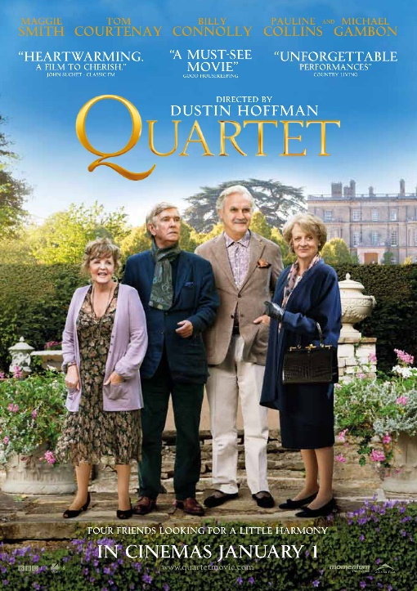
- What is the likely resolution of this DVD cover? ___________________________________
- What file type would probably have been used to save this graphic? __________________
- Why would this have been a suitable file type for this graphic? ___________________________________________________________________________________________________________________________________________________________________________________________________________________________
- What is the overall purpose of this graphic? ______________________________________
_________________________________________________________________________

